IPv6 addressing

Hexadecimal number system

Before diving into IPv6, its important that you know that IPv6 addresses are represented using hexadecimal numbers

**Sixteen number system uses 0-9 and A-F**

**0 1 2 3 4 5 6 7 8 9 A B C D E F**

In IPv6 addresses, these 16 digits are represented as hextets allowing us to represent these massive addresses in a much more readable format

IPv6 addressing formats

IPv6 addresses are much larger than IPv4 addresses, which is why we are unlikely to run out of them

**IPv6 addresses are 128 bits in length and written as string of hexadecimal values**

**Every 4 bits - represented by a single hexadecimal digit for total of 32 hexadecimal values**

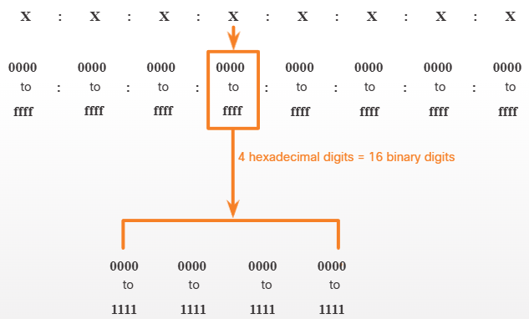

Preferred format:

Preferred format for writing IPv6 address is x:X:X:X:X:X:X:X:X,

With each “x” consisting of 4 hexadecimal values

**Hextet - segment of 16bits or 4 hexadecimal values**

**Each “x” is hextet**

IPv6 formatting rules video

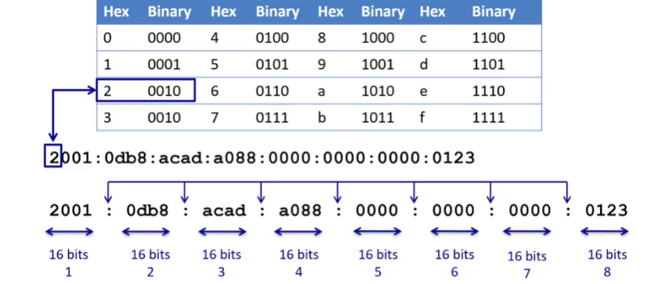

Rule 1 - omit leading 0 (zeros)

Omit any leading 0s in any hextet

01ab --> 1ab

09f0 --> 9f0

0a00 --> a00

00ab --> ab

**ONLY LEADING 0s NOT TAILING 0s**

2001:0db8:0000:1111:0000:0000:0000:0200

2001:db8:0:1111:0:0:0:200

2001:0db8:0000:00a3:ab00:0ab0:00ab:1234

2001:db8:0:a3:ab00:ab0:ab:1234

...

Rule 2 - double colon

Double colom (::) can replace any single, contiguous string of one ore more 16-bit hextets consisting of all 0s

2001:db8:cafe:1:0:0:0:1 --> 2001:db8:cafe:1::1

**IT CAN BE USED ONLY ONCE WITHIN AN ADDRESS**

2001:0db8:0000:1111:0000:0000:0000:0200

2001:db8:0:1111::200

2001:0db8:0000:0000:ab00:0000:0000:0000

2001:db8:0:0:ab00::

Fe80:0000:0000:0000:0123:4567:89ab:cdef

Fe80::123:4567:89ab:cdef